OSINT4Fun Advent of OSINT 2024: Day 1

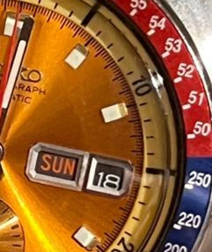

*This watch, of which part is visible, has become legendary.*

*On what date (format YYYMMDD) did it take off?*

Let’s start with a Google reverse image search. Many similar images are found. Close-ups reveal that this watch is a Seiko Chronograph Automatic. I’m curious why this watch is legendary, so I Google for: “Seiko Chronograph Automatic”. Looking at the images that appear, they look different (no red and blue ring). So I must need more specification for this type of watch. For this, I return to the Google reverse image search results. I often see referrals to Pogue, so let’s add this to the Google query. This reveals images that much more resemble this watch. Under the “People also ask” section there is a question “What number is the Seiko Pogue?” which has me intrigued since the Google reverse image search showed a lot of mentions of the number 6139. The answer to this question explains that the number 6139-6005 is associated with this watch. Clicking on the answer to this question brings me to a website called plus9time.com, which has a whole article about this exact watch. The page describes the probable reason why this watch is legendary: it was the first automatic chronograph in space, worn by Colonel William Reid Pogue. Now I understand the strange formulation of the question: it makes reference to the launching of the rocket used in this space mission. The answer is also revealed on this page: the Skylab 4 mission started on November 16, 1973. Hence, the answer to this question is: 19731116.